Marxism and the Transition to Capitalism: A Dialectical Critique

By
Kanokphan Sirithienthong | 6610750092
Phurin Meechanchuang | 6610754250
Monprach Pattamakeansai | 6610750459
Athipat Suriam | 6610750629
Nathorn Apichaikriengkrai | 6610750190
Rapeerat Chen | 6610750483

Section 415
Submitted to:
Assoc.Prof. Kanokwan Chancharoenchai, Ph.D

History of Economic Thought
Bachelor of Economics (English Program)
Kasetsart University

First Semester, Academic Year 2025

Abstract
This report examines the historical and ideological shift from Marxist theory to capitalist practice, focusing on how Marxist-inspired systems evolved, adapted, or retreated in the face of internal contradictions and global economic pressures. Drawing conceptual grounding from Chapter 7 of the study material on socialism, it explores the foundational principles of Marxism — including dialectical materialism, surplus value, and class struggle — and contrasts them with the eventual emergence of capitalist reforms in formerly socialist states. Visual models such as Marx’s Social Pyramid, the Surplus Value Cycle, and Structural Interactions are used to trace this reversal. The report highlights how Marxist ideals were reinterpreted or abandoned, offering a critical lens on the resilience of capitalism and the contested legacy of Marxist thought in the modern world.
Introduction
The evolution of economic systems has long been a central concern of political economy, and few thinkers have shaped this discourse as profoundly as Karl Marx. Rooted in dialectical materialism, Marxism offered a revolutionary critique of capitalism and envisioned its eventual replacement by socialism and communism. Yet history has shown a more complex trajectory — one in which Marxist-inspired societies often transitioned not toward socialism, but back toward capitalist structures.
This report explores how Marxist theory, once positioned as a transformative force against capitalism, has in many cases been reabsorbed or reversed through political reform, economic liberalization, and global market integration. From the collapse of the Soviet Union to China’s market reforms, the shift from Marxist ideals to capitalist realities reflects both internal contradictions and external pressures. Rather than a linear progression toward socialism, the historical arc reveals how capitalism has reasserted itself — often within systems originally built to dismantle it.
By tracing this reversal, the report examines Marx’s theoretical foundations, the structural critique of capitalism, and the forces that led Marxist regimes to adopt capitalist mechanisms. It also considers the legacy of Marxist thought in a world increasingly dominated by market logic, offering insight into the resilience of capitalism and the contested relevance of Marxism today.
Foundations of Marxism
Marxism is grounded in a philosophical framework known as dialectical materialism, which interprets historical development as a dynamic process driven by contradictions between material forces and social relations. This concept synthesizes Hegel's dialectical method — the progression from thesis to antithesis to synthesis — with Feuerbach's materialism, which replaces idealist abstractions with tangible economic realities. Marx applied this fusion to the economic system, arguing that history unfolds through class conflict rooted in the organization of production.
At the heart of Marxism lies the class struggle — a recurring conflict between dominant and subordinate classes. In the capitalist era, this manifests as the antagonism between the bourgeoisie (owners of the means of production) and the proletariat (workers who sell their labor power). This struggle is not merely distributive but structural, embedded in the very logic of capitalist production and exchange.
Marx rejected the notion that ideas alone drive historical change. Instead, he argued that material conditions — the ownership of land, labor, capital, and technology — shape the superstructure of society, including its laws, politics, and culture. As the forces of production (e.g., technology, labor skills) evolve, they eventually clash with existing relations of production (e.g., wage systems, property rights), creating systemic tension.
This framework inspired revolutionary movements and state-building efforts throughout the 20th century. However, many Marxist regimes later faced contradictions between ideological purity and practical governance. The very material forces that Marx emphasized — industrialization, global trade, and technological advancement — often pushed these systems toward market reforms and capitalist adaptation. As such, the foundational principles of Marxism became sites of negotiation, reinterpretation, and in some cases, abandonment.
Figure 1: Marx's Social Pyramid illustrates the original Marxist view of how the superstructure is shaped by economic foundations. In later transitions, this model was challenged as states restructured their economies to accommodate capitalist mechanisms, even while retaining socialist rhetoric.

Figure 1: Marx’s Social Pyramid
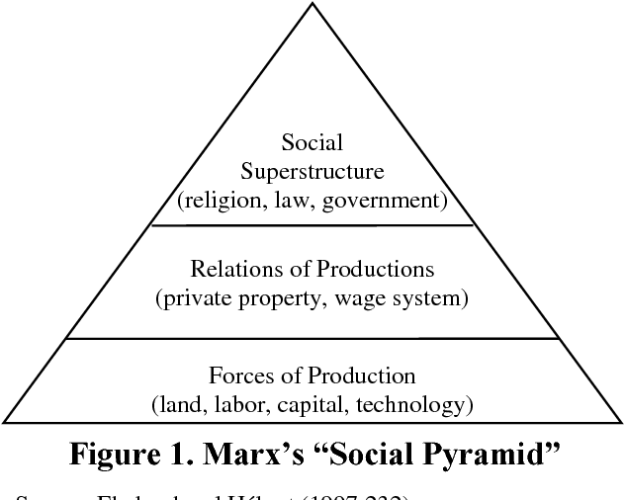
Marx’s View of Capitalism
Marx’s analysis of capitalism centers on its structural exploitation and internal contradictions. He argued that capitalism commodifies labor, extracting surplus value from workers who produce more than they are compensated for. This surplus — the unpaid portion of labor — becomes the source of profit for capitalists, reinforcing class divisions and systemic inequality.
At the core of this critique is the Labor Theory of Value, which asserts that the value of a commodity is determined by the socially necessary labor time required for its production. Under capitalism, however, labor itself becomes a commodity, and its true value is obscured by market prices. Marx formalized this in the equation:
C′ = c + v + s, where c is constant capital (machinery, materials), v is variable capital (labor), and s is surplus value — the unpaid labor appropriated by capitalists.
This mechanism is illustrated in Figure 2: Marx’s Surplus Value Cycle, which shows how capital circulates through the transformation of money into commodities and back into expanded capital (M → C → M′). The cycle reveals how profit is not generated by exchange, but by exploitation embedded in production.
Figure 2: Marx’s Surplus Value Cycle
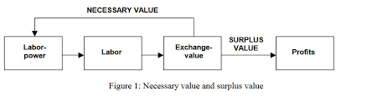
Marx believed that this system, while historically necessary for developing productive forces, would eventually collapse under the weight of its contradictions — including falling profit rates, alienation, and class polarization. He envisioned a revolutionary transition in which the proletariat would seize control of the means of production and abolish capitalist relations.
However, in many Marxist-inspired states, this critique of capitalism was later tempered by pragmatic reforms. Facing economic stagnation, inefficiencies, and global competition, several regimes began to reintroduce market mechanisms, private enterprise, and foreign investment. Ironically, the very capitalist dynamics that Marx critiqued were selectively adopted to stabilize or grow socialist economies.
Thus, while Marx’s critique remains analytically powerful, the historical trajectory of Marxist systems reveals a reversal: from revolutionary opposition to strategic accommodation of capitalism. This shift sets the stage for understanding how Marxist theory was transformed — not only by its internal logic but by the pressures of global capitalism.
Internal Contradictions of Capitalism
Marx argued that capitalism is inherently unstable, driven by contradictions that intensify over time. These include the tendency of the rate of profit to fall, the alienation of labor, and the cyclical crises of overproduction and underconsumption. As capitalists invest more in machinery and technology (constant capital, c) relative to labor (variable capital, v), the organic composition of capital increases. Yet only labor produces surplus value (s), leading to a declining rate of profit over time — a structural limit to capital accumulation.
To counteract this decline, capitalists intensify exploitation by extending working hours, suppressing wages, or increasing productivity. However, these strategies have diminishing returns. Alienation deepens as labor becomes deskilled and disconnected from the production process. Technological advancement also creates a reserve army of unemployed workers, further destabilizing wage structures and social cohesion.
These contradictions were not only theoretical but manifested within Marxist regimes themselves. While founded on anti-capitalist principles, many socialist economies encountered stagnation, inefficiency, and internal discontent. Attempts to suppress market dynamics often led to shortages, bureaucratic rigidity, and declining productivity. In response, leaders in these systems began to reintroduce capitalist mechanisms — market pricing, private enterprise, and foreign investment — as pragmatic solutions to systemic dysfunction.
Ironically, the contradictions Marx identified in capitalism also emerged within Marxist economies, prompting a reversal of ideological commitments. The shift from centralized planning to market liberalization was not merely economic but ideological: a retreat from Marxist orthodoxy in favor of capitalist adaptation. This reversal underscores how internal contradictions — whether in capitalist or socialist systems — can drive transformation, often in unexpected directions.
From Marxist Ideals to Capitalist Realities
Marx envisioned capitalism as a transitional system destined to collapse under its own contradictions, giving way to socialism and eventually communism. In theory, this transformation would be driven by the rising consciousness of the proletariat, culminating in a revolutionary rupture that dismantled capitalist institutions and restructured society around collective ownership and democratic control of production.
However, the historical trajectory of many Marxist-inspired states diverged sharply from this vision. Rather than progressing toward socialism, several regimes — including the Soviet Union, China, and Eastern European nations — experienced a reversal. Confronted with economic stagnation, inefficiencies, and global competition, these governments began to adopt capitalist mechanisms: market pricing, private enterprise, foreign investment, and trade liberalization.
This shift was not merely tactical but ideological. The revolutionary thesis of Marxism gave way to a pragmatic synthesis that blended socialist rhetoric with capitalist practice. The state, once envisioned to “wither away,” instead became a manager of market reforms. Class distinctions persisted, and in some cases, deepened under new forms of inequality and privatization.
Figure 3: The Dialectical Process, originally used to illustrate the transition from capitalism to socialism, now serves as a lens to understand the reverse movement — from Marxist foundations back toward capitalist structures. The synthesis, rather than abolishing class, often reconfigured it within a market framework.
Figure 3: The Dialectical Process
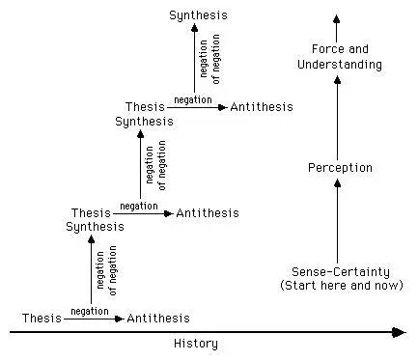
This reversal underscores the tension between ideological purity and material necessity. While Marxist theory emphasized historical inevitability, real-world conditions — technological change, global trade, and internal contradictions — pushed many systems toward capitalist adaptation. The result is a complex legacy: one in which Marxist ideals were not fully realized, but instead reinterpreted or abandoned in pursuit of economic survival.
Marxism’s Legacy and Critique
Marxism has left a profound imprint on political thought, revolutionary movements, and economic experimentation. Its structural analysis of capitalism — centered on class struggle, surplus value, and systemic contradictions — provided the ideological foundation for numerous 20th-century regimes. From the Soviet Union to Maoist China, Marxist principles shaped state institutions, economic planning, and social policy.
Yet the legacy of Marxism is marked not only by its influence but by its transformation. Many regimes founded on Marxist ideals eventually embraced capitalist reforms, either gradually or abruptly. The collapse of the Soviet bloc, China’s pivot to market socialism, and Vietnam’s Doi Moi reforms all reflect a broader pattern: the retreat from centralized planning and collective ownership toward privatization, competition, and global integration.
This reversal has prompted both theoretical and practical critiques. Some argue that Marx underestimated capitalism’s adaptability and overestimated the revolutionary potential of the working class. Others contend that Marxist theory failed to account for the complexities of governance, innovation, and global interdependence. Attempts to implement Marxist economies often struggled with inefficiency, authoritarianism, and suppression of dissent — outcomes that undermined the theory’s emancipatory promise.
Contemporary Marxist scholars have responded by reinterpreting the framework. Neo-Marxism, autonomist Marxism, and critical theory have expanded the lens to include culture, ideology, and identity. These approaches explore how class intersects with race, gender, and colonial histories, making Marxism more responsive to modern conditions — even as capitalist systems remain dominant.
Figure 5: Structural Interactions in Marxist Theory illustrates the dynamic relationships between class struggle, economic structure, and state power. In practice, these relationships have evolved under pressure, often reshaping Marxist institutions into hybrid models that accommodate market logic while retaining socialist symbolism.
Figure 4: Structural Interactions in Marxist Theory
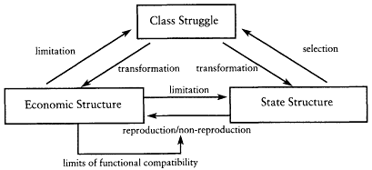
In today’s global economy, Marxism persists more as a critical tradition than a governing blueprint. Its legacy is contested — celebrated for its analytical power, critiqued for its historical outcomes, and continually reexamined in light of capitalism’s resilience. The transition from Marxist ideals to capitalist realities invites reflection not only on what was lost, but on what remains relevant in the pursuit of economic justice and systemic change.
Conclusion
The historical journey from Marxist theory to capitalist practice reveals a complex and often paradoxical transformation. While Marxism offered a rigorous critique of capitalism and a vision for its transcendence, many regimes founded on these ideals ultimately adopted the very market mechanisms they once opposed. This reversal was not merely a political shift but a structural response to internal contradictions, global pressures, and evolving material conditions.
Through its analysis of surplus value, alienation, and systemic instability, Marxism remains a powerful lens for understanding the dynamics of capitalist economies. Yet the retreat from Marxist orthodoxy in favor of capitalist adaptation underscores the resilience of market systems and the challenges of implementing ideological alternatives.
As illustrated throughout this report — and supported by visual models such as Figure 1: Marx’s Social Pyramid, Figure 2: Marx’s Surplus Value Cycle, Figure 3: The Dialectical Process, and Figure 4: Structural Interactions in Marxist Theory — the transition from Marxist ideals to capitalist realities is not a simple abandonment, but a layered negotiation between ideological intent and material adaptation.
Today, Marxism persists more as a critical tradition than a governing framework. For economists, consultants, and policy designers, engaging with its insights remains essential — not to revive a lost system, but to interrogate the foundations of the one that prevailed. In doing so, we gain not only analytical clarity but a deeper understanding of the forces that shape economic transformation.
Reference
Chapter 7: Socialism. Provided as study material in the course History of Economic Thoughts, Kasetsart University, Bang Khaen Campus.
“Hegel and the Trinity.” Book of Threes. Available at: https://www.bookofthrees.com/hegel-and-the-trinity
Widodo, J. (2008). Marx's Capital: The Revolt Against Classical Economics. Semantic Scholar. Available at: https://www.semanticscholar.org/paper/Marx's-capital%3A-the-revolt-against-classical-Widodo/1b6ef99899dd17af237418ae869d135fb97c9b01.
Resch, R. P. (1992). Althusser and the Renewal of Marxist Social Theory. In The Political Economy of Class Structure. University of California Press. Available at: https://publishing.cdlib.org/ucpressebooks/view?docId=ft3n39n8x3&chunk.id=d0e4919&toc.id=&brand=ucpress.

